Phase 1: Drop off
Point of drop off: https://www.google.com/maps/place/38%C2%B053'03.1%22N+77%C2%B003'51.8%22W/@38.884192,-77.0649677,617m/data=!3m2!1e3!4b1!4m13!1m6!3m5!1s0x89b7b7876e5ec839:0xaeab3278c6b40a49!2sUS+Capitol+Grounds!8m2!3d38.8898173!4d-77.0081959!3m5!1s0x0:0x0!7e2!8m2!3d38.8841919!4d-77.0643885

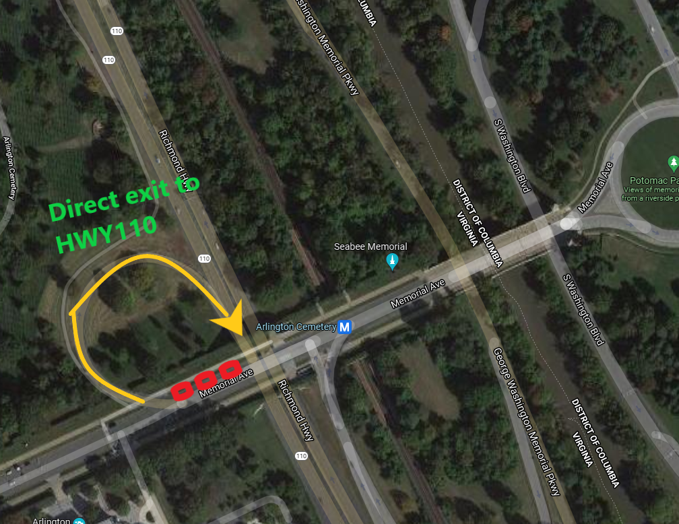

Description: At point of drop off 3 vehicles will stop, unload and then make their escape by simply turning onto HWY 110 which entrance ramp will be 150-300ft away.

Phase 1.1: Vehicle waiting spots.
Once turning onto HWY110 vehicles will proceed to their waiting spots. Vehicles need to be as close as possible to each other while also separated. We want to make sure we don’t disperse them which will cause logistical issues when they will do the pickup and most importantly delays and different ETA’s. That is why before pickup they first must assemble, assume the order in which they were at drop off and then leave in orderly formation once we reach Lincoln memorial which will mark approx. 8-10 minutes ETA for the marching columns to arrive to original drop off. This will ensure that the vehicles will arrive in time and will minimize their exposure to 2-5 minutes.

Waiting points:
Vehicle 1 (Leading vehicle)
[Withing 1.5 mile of radio distance]
https://www.google.com/maps/place/38%C2%B052'43.2%22N+77%C2%B003'13.4%22W/@38.878679,-77.0542692,308m/data=!3m2!1e3!4b1!4m6!3m5!1s0x0:0x0!7e2!8m2!3d38.8786795!4d-77.0537217
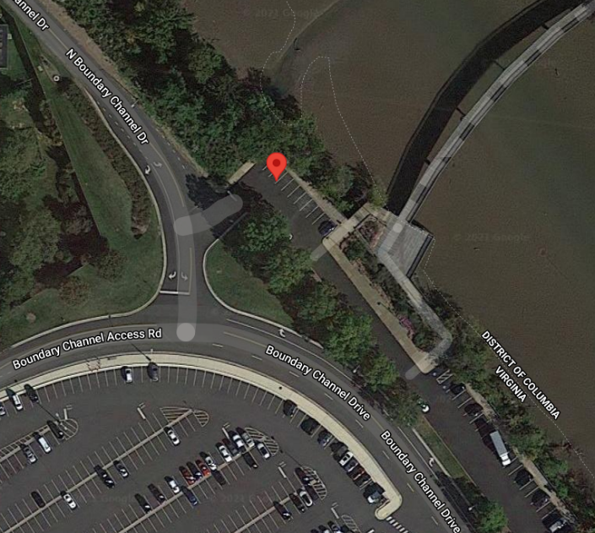

Vehicle 2 & 3

Both vehicles will be at each end of the parking lot waiting. 3 Penske trucks in one parking lot may attract too much attention which is why Vehicle 1 will be 3 minutes away from them at a different lot.

[ Within ~ 1.7 mile of radio distance]
https://www.google.com/maps/place/38%C2%B052'34.8%22N+77%C2%B003'00.0%22W/@38.8763418,-77.0509222,613m/data=!3m2!1e3!4b1!4m6!3m5!1s0x0:0x0!7e2!8m2!3d38.8763403!4d-77.0500016

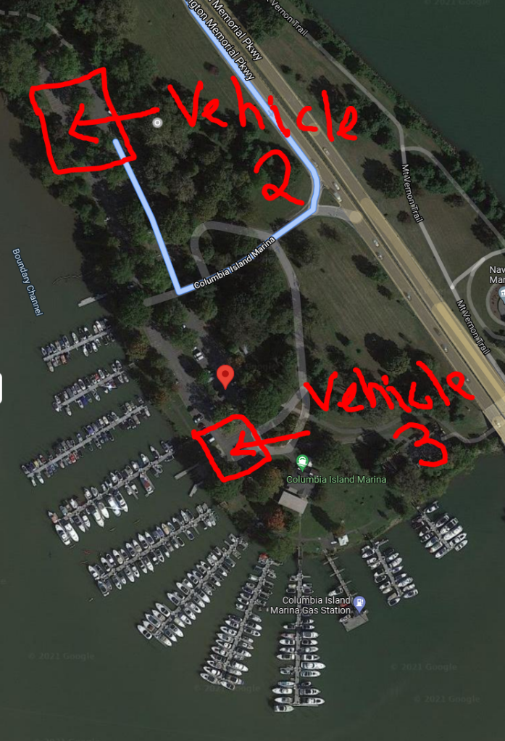

Phase 1.2: Assembly point
As ground units approach to pick up, At estimated 15 minutes before pickup which will be the passing of Lincoln memorial, GRANT MD will give command of vehicle assembly at the point described below [which will be the lot where vehicle 2 and 3 are]. The vehicles will assemble, get into their original order and then proceed to the PICK UP location.
https://www.google.com/maps/place/38%C2%B053'03.1%22N+77%C2%B003'51.8%22W/@38.8754581,-77.0500732,512m/data=!3m1!1e3!4m13!1m6!3m5!1s0x89b7b7876e5ec839:0xaeab3278c6b40a49!2sUS+Capitol+Grounds!8m2!3d38.8898173!4d-77.0081959!3m5!1s0x0:0x0!7e2!8m2!3d38.8841919!4d-77.0643885

Phase 2: March
LEGEND: = SHIELD CROSSING
2.1 Drop to Lincoln Memorial
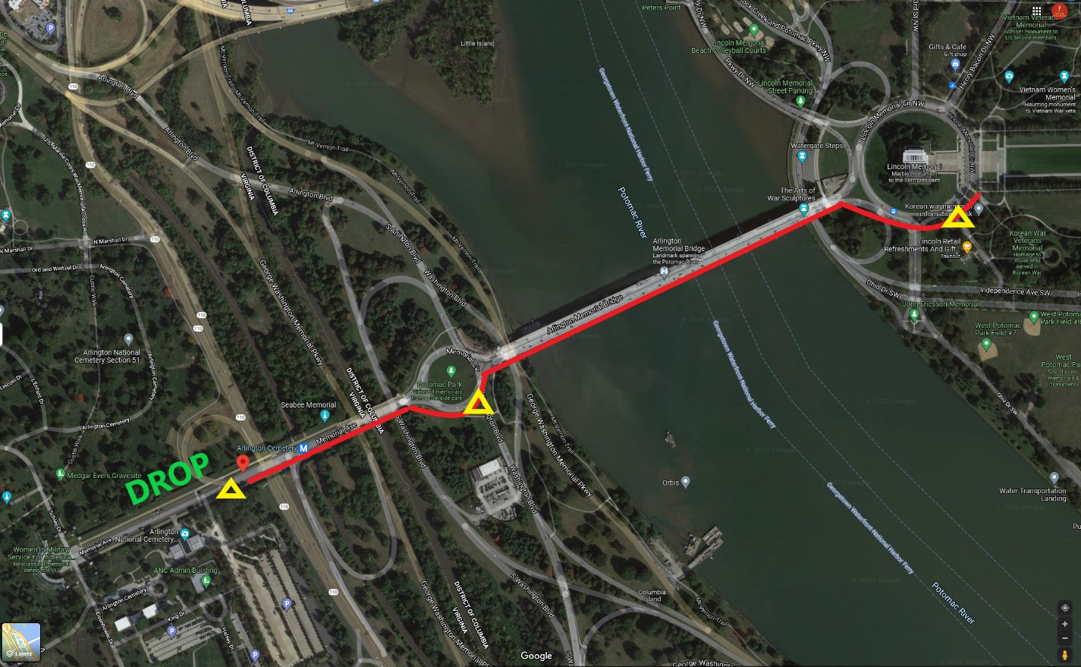

Once disembarked, columns must cross because this will be the most expedient and safest spot to cross. Shields will block traffic the points shown above which should be an easy task being at this point cars will be moving at slow speeds.

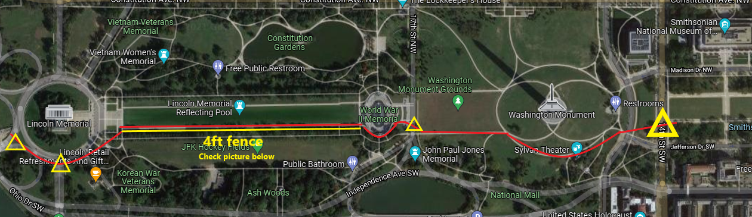
2.1. Lincoln Memorial to Washington Monument

IMPORTANT: Along the Lincoln reflecting pool (Only on that side) thre is a approx. 4ft chain fence. THIS SECTION WILL BE NARROW, WE WILL NEED TO MARCH IN 3 COLLUMS.
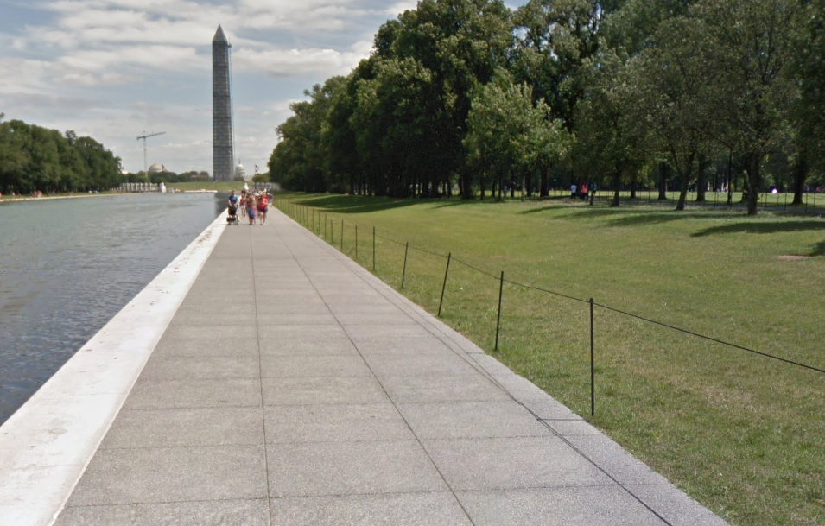

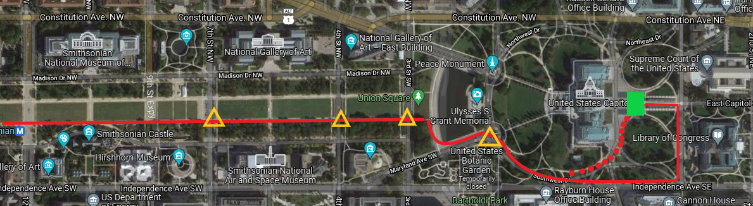
2.2. Washington Monument to Capitol.

Approaching the Capitol: 2 options of approach:
- Option #1 – Is marked with the red continuous line. Which would be going around to First Street and marching towards the Capitol\
- Option #2 – Marked by the Red Dots which would we to cut through on to to the side of the Capitol and find ourselves at the speech position marked by the Lime Green Rectangle.
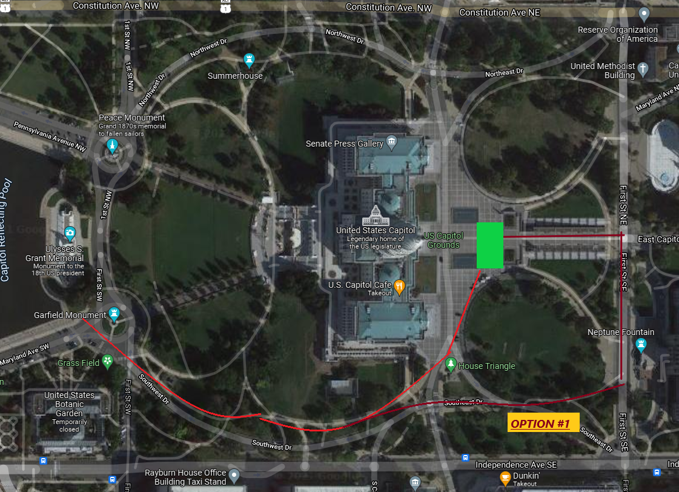

Phase 3: Speech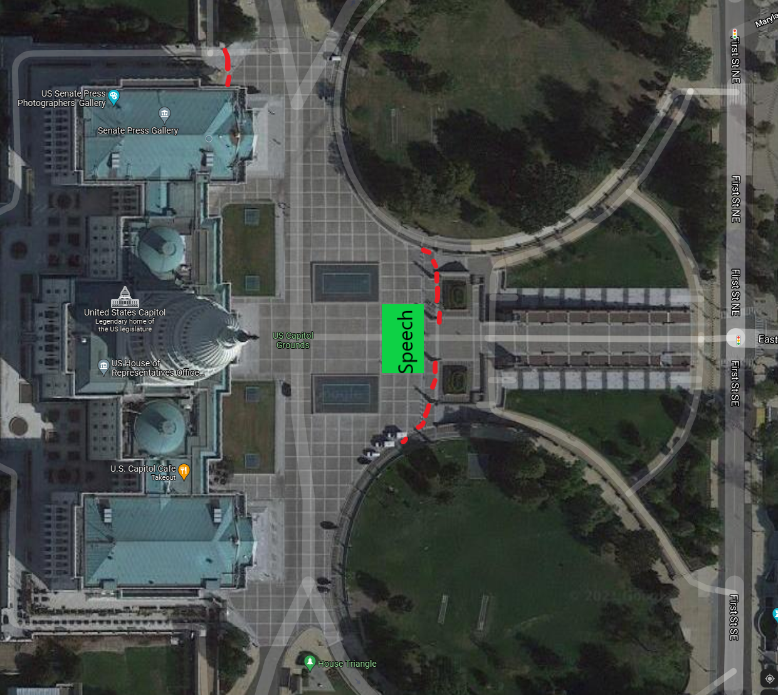

!!!!!OBSERVED BARRICADES ARE MARKED IN RED STAGGER LINES

Phase 4: March Back
With the speech over, we will have 3 points of exit:
- Path A
- Path B [Go towards First St and circle around]
- Path C [Same way we came from]

PATH A
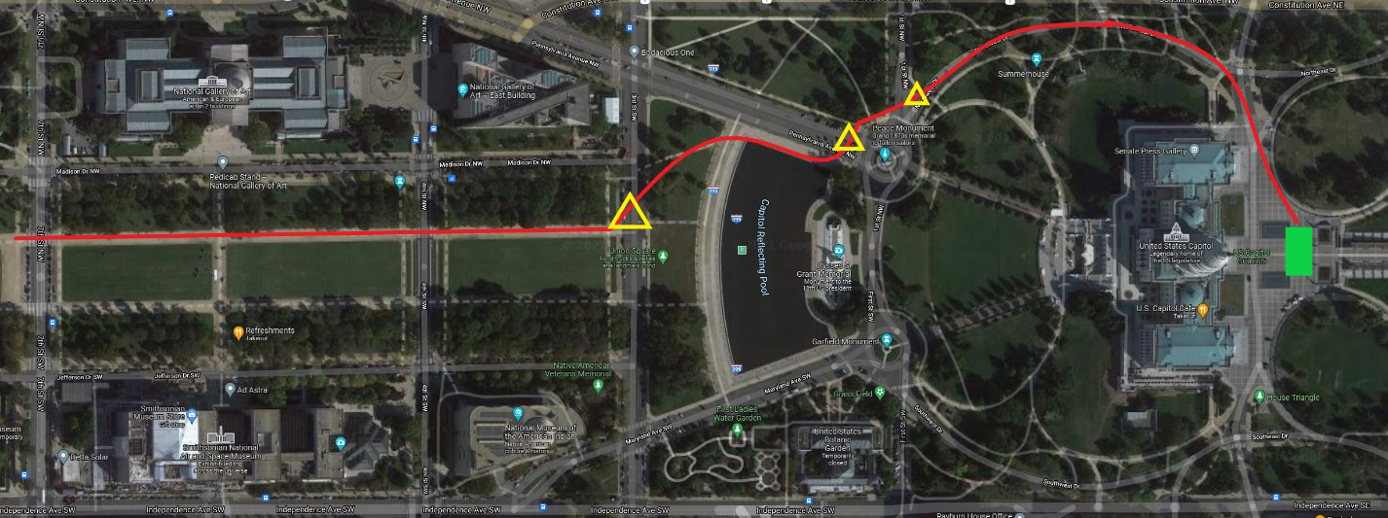
PATH B
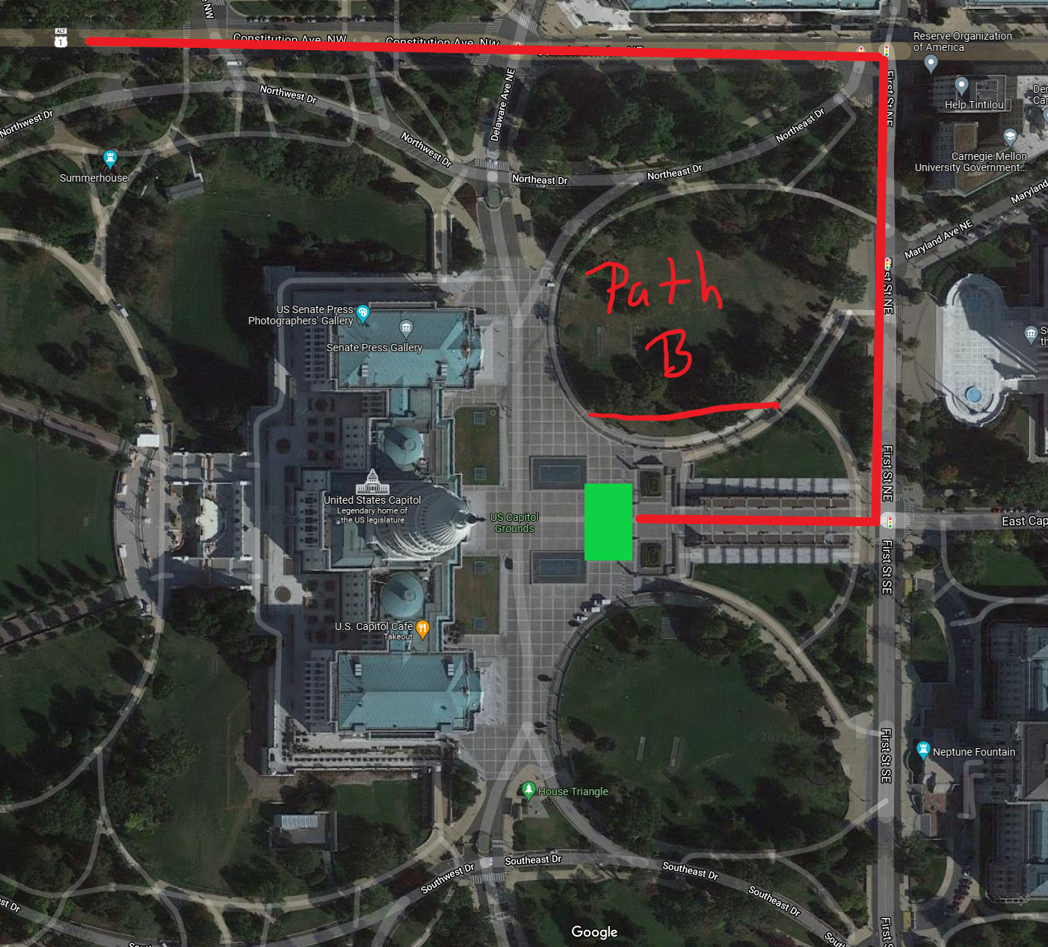
If trapped or blocked off, we can exit towards First Street.and then take a left on Constitution and proceed with our march

PATH C – Exit the same way we came
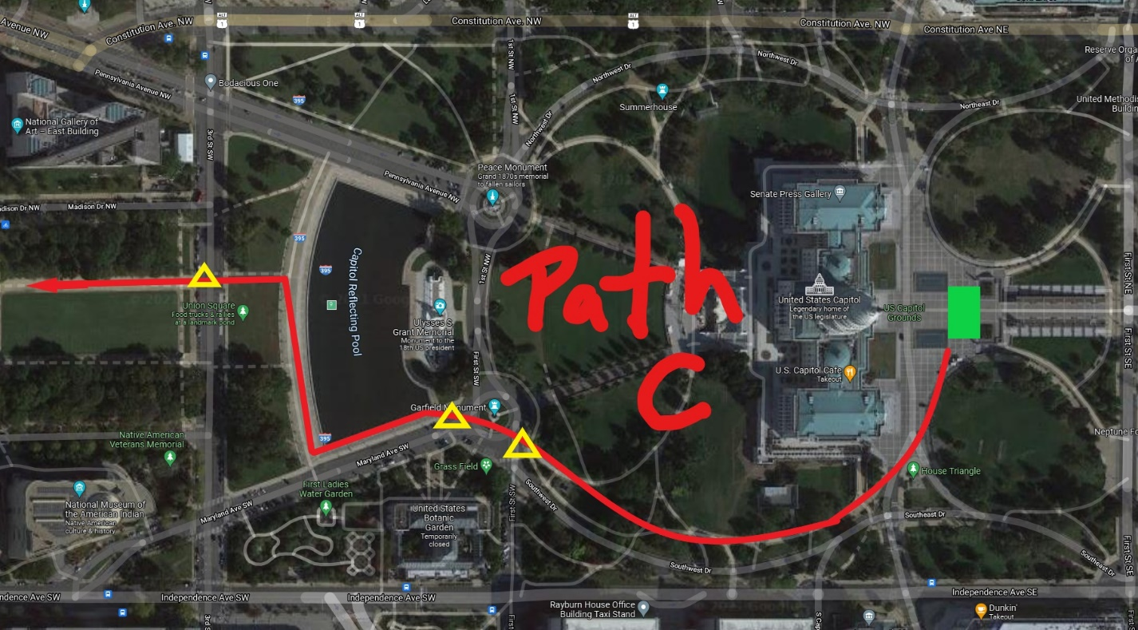

Phase 4.2 : Up to Lincoln Memorial
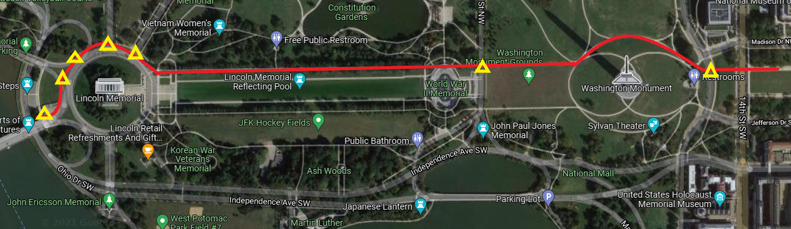

Phase 5: Exfil
When marching column reaches WW2 memorial. Vehicles will be ordered to assemble back in formation at the assembly point.
Once the column reaches Lincoln Memorial, Grant MD will give order to proceed to exfil, ETA from assembly point to Exfil 5-6 min which will ensure that the vehicles will be exposed at the Exfil for 3-4 minutes.
WE WILL HAVE TWO OPTIONS:
- Vehicles circle around Potomac park until ground units arrive for approx. 2-4 minutes.
- Vehicles stop on S. Arlington St at the shoulder where the 3 vehicles can be parked until we arrive
Option One
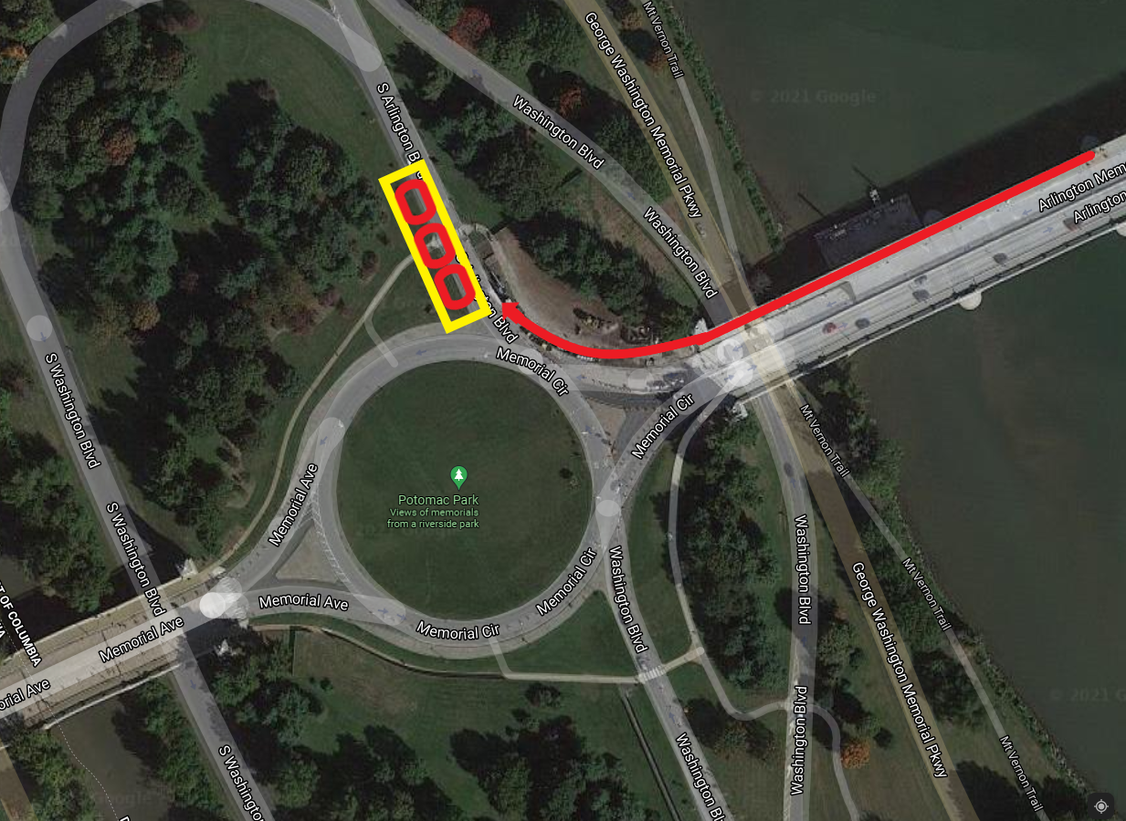

The vehicles could stop here and wait, all 3 of them will be able to fit
