17 Days at Chosin

American Tenacity on Display

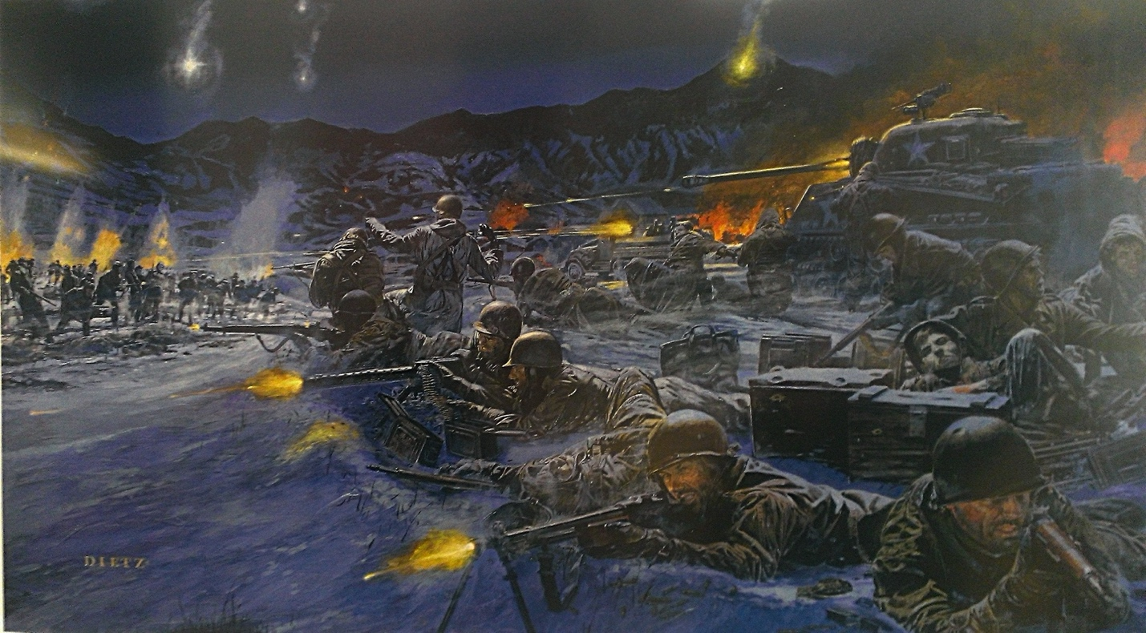

The Chosin Reservoir lies deep in the freezing wastes of the Northeast Korean peninsula. During the Korean War, this area would become the site for a display of American heroism, endurance, and courage. 17 days of hard fighting and freezing weather would see America’s sons facing the trials and tribulations that their forefathers faced in similar conditions at Valley Forge, and by inducing their ancestors’ spirits they awoke the warrior spirit within all sons of Columbia to fight their way out when beset on all sides by one of America’s worst enemies, Communism.

Background:

The Chosin Reservoir itself is a manmade lake located within the northeastern part of the modern-day North Korea. The name itself is derived from a Japanese pronunciation of the Korean Changjin, which alludes to the outdated Japanese maps the American forces found themselves issued in preparation for the battle. Inefficient bureaucracy, poor planning, and foolhardy generals (not much unlike other foreign wars the State’s war machine has engaged in
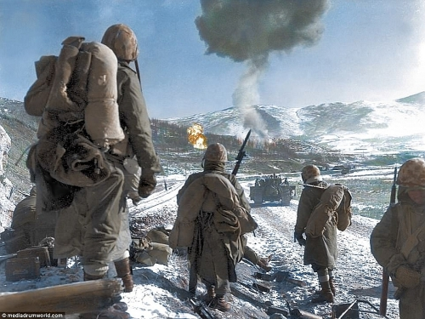
at the detriment of the nation’s people) had severely underestimated the Chinese People’s Liberation Army’s strength. Over 150,000 Communist troops had found themselves infiltrating the Korean border and unbeknownst to the incompetent American staff, were geared straight for the Chosin Reservoir in an attempt to lure the American Eighth Army into her destruction. The overconfident generals at this point were in the midst of what was deemed the “Home-By-Christmas” offensive, which was more geared towards a propagandic success back home than its proposed military objectives. This poorly planned action directly cost many American lives and can remind one of the numerous blunders the State has perpetrated for the interests of those elites who would squander America’s God-given bounty.

17 Days:

At the outset of the battle, poor intelligence and overconfidence led to the significant underestimate of Chinese forces. The X Corps was the main combatant force, comprised of both American forces and our Anglo cousins. The Corps found itself immediately surrounded by over a hundred thousand Chinese all streaming through the crevices and passes of the Reservoir. Beset on all sides, panic quickly set in among the more craven of officers, however the actions of those with the Columbian spirit, such as Lewis “Chesty” Puller, quickly instilled the morale and will to fight within the men.

Meanwhile, on the Western Front across the peninsula, American forces were in full retreat after the disastrous Battle of the Ch’ongch’on River. The senior officers decided to order the entrapped American and Anglo forces to break out in a southeasterly direction for safer ground.

“Retreat, hell! We’re not retreating, we’re just advancing in a different direction!” -Major General Oliver P. Smith

The X Corps would inflict heavy casualties onto their enemies as they advanced south, despite having to move on narrow mountain passes and cope with freezing weather. The brave flyers of the US Air Force soared above, dropping bombs all over the Chinese positions and killing hundreds, also disrupting badly needed logistics and supply lines at the same time. US Marines and Army Infantrymen fought tooth and nail, and in some cases with their hands, against entrenched Chinese positions who fought as hard as they could to extinguish the fire of American wrath descending upon them. In some cases, Marines would even fight their way into Chinese foxholes to find that their enemies had frozen to death.

The Communist High Command was shocked to find the numerically inferior and outgunned Americans smashing apart any forces that came into their path, and over the course of the battle would commit over an extra 30,000 forces on top of the initial 100,000 they had committed. They launched the most desperate of tactics, including human waves and mass frontal assaults. On average, however, the average American soldier found himself far more robust of frame and taller and stronger than his Chinese enemies, and in cases of hand to hand combat the larger frames of the Americans would prevail over the numerically superior waves of Sino Communists.

Eventually, the Americans would find their way back to the port of Hungnam, where they were evacuated while the steel guns of the fearsome American Navy rained hellfire down upon the heads of their Communist pursuers. Although strategically the Americans would have to cede the territory itself to the Communists, the Communist Army was so badly mauled that their hopes of conquering the entire Korean peninsula were permanently ended.

Lessons to Learn from Chosin:

The virtues of American patriotism and martial supremacy was on full display at the Chosin Reservoir. Despite the freezing wastes they fought upon and the incompetent generals that oversaw them, American men banded together to fight their way out against all odds, not having the edge in numbers, firepower, or strategic location. The State may resemble the Communists in many ways, having a large number of resources and overbearing control at its disposal, however battles like Chosin showcase the American spirit of revolt against tyrannic forces that would vanquish it.

Muistoja Pohjolasta: Why I Used the Finns for the Melody:

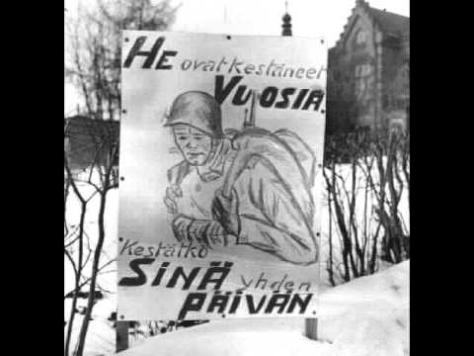
Throughout history, nationalist movements have taken inspiration from each other to build upon their foundations and provide a cultural revolution for their adherents. My logic for using the particular song “Muistoja Pohjolasta” as the rhythm and melody for the marching song I composed, “17 Days at Chosin”, has a couple of reasons. First, for those who are familiar with the Winter War, conditions were like the Battle at Chosin, being characterized by fierce winter conditions and hard fighting against Communist invaders. There are thousands of Americans descended from these same Finns who fought so hard against the Bolsheviks, and so we all carry the spirit of their fight as in solidarity with the Pan-European ideology we are aligned to. For all my songs that I compose I use numerous European melodies, whether they be German, Italian, French, or otherwise. America’s sons are descended from all these nationalities, and as such we Americans share a culture that is defined by the Latin phrase E Pluribus Unum, or “out of many, one”.
1 The translation reads "They have endured the cold for years; can you stand it for one day?

17 Days at Chosin
Lyrics composed by Arthur FL
Rhythm and melody attributed to Muistoja Pohjolasta.
https://www.youtube.com/watch?v=C4jHY8h05jE

Far from lands of warm and sun, America’s hardened soul
Guns and the fury of our hearts, we shall fight unto our goal!
Evil forces vanquished on the lands of Korea
17 Days of Chosin struggle, the sons of Columbia!

Instrumental Break

Now we stand under the flag of our forefathers’ pride
Descended from the wars of might, our destiny, we decide
Reclaim the lands of the nation’s noble cause
17 Days of Chosin struggle, the sons of Columbia!

